* **Offset(A1,1,2,3,4)** means A1 initial reference point(initial location),move 1 row down,move 2 column right and this becomes the final reference point(final changed location), total 3 rows(height),total 4 columns(width). - This function returns a specified number of rows and columns from a specified range.

<https://www.youtube.com/watch?v=PKNMwVqIaYk>

* != is equivalent to <> in excel.
* Excel is case in-sensitive.A1=a1 and apples=APPLES in excel.
* The COUNT() counts the number of cells that contain a number,

The **COUNTA()**  counts the number of cells that are not blank.

The **COUNTBLANK()**  count the number of empty cells.

* FlashFill - Ctrl+E –

<https://www.youtube.com/watch?v=I13_zkuu_nI>

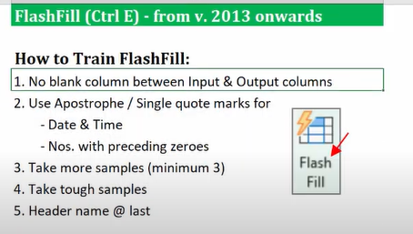

|  |  |
| --- | --- |
| Sample Input | Sample Output |
| Input |  |

* **Indirect()-** Indirect() is used for references within the same workbook.

<https://www.youtube.com/watch?v=uvSi2h-J8nA>

* The **ROW()** returns the row number of a reference you enter in a formula.
* The COLUMN**()** returns the column number of a reference you enter in a formula.
* Index(Match)= XLOOKUP(lookup value, lookup array=column, XLOOKUP(lookup value, lookup array=row, return array=table array))
* Ctrl+K - For linking to websites/place in this document
* CTRL + ENTER – This applies the same contents or formula in all the cells you initially select.

<https://www.youtube.com/watch?v=sjYfP8Tt5O4>

* CTRL+G – Used to open the **"Go To"** dialog box.Itallows one to quickly select all cells that meet certain criteria, such as cells containing: Formulas (numbers, text, errors), blanks.

<https://www.youtube.com/watch?v=qpHsWpuk7zE>

* **How to Insert a blank row after every data row in Excel-**

|  |  |
| --- | --- |
| **1** | **A** |
| **2** | **B** |
| **3** | **C** |
| **4** | **D** |
| **1** |  |
| **2** |  |
| **3** |  |
| **4** |  |

Select the table and sort it by ascending.

<https://www.youtube.com/watch?v=nojEC3i2YX4&list=PLrR4-diP9nFQMwAHNWCYG_5SDT_3boIYP&index=23>

* Text to Columns – Destination-Choose a blank cell in order to retain original data.
* Find & Replace –
* **Formula based Conditional formatting –** Conditional Formatting->New Rule->Use a formula to determine which cells to format->write the formula so that it results in TRUE/FALSE->OK

[Formula based Conditional formatting | MIS Reporting Tricks (youtube.com)](https://www.youtube.com/watch?v=5_rUkIEfvtk&list=PLrR4-diP9nFQMwAHNWCYG_5SDT_3boIYP&index=38)

* **Ctrl+T** – Insert Table.
* Compare 2 Excel files – Open 2 files->Inquire->Compare Files->Select 2 files->Compare.
* Find “Cust_ID” wise total value and count of transactions between 2 dates.

[Advanced SUMIFS for Date Ranges - NOT for BEGINNERS | Excel in Hindi (youtube.com)](https://www.youtube.com/watch?v=FrACxPTUJdo&list=PLrR4-diP9nFQMwAHNWCYG_5SDT_3boIYP&index=50)

* IFS() - IFS(logical test1, value1 if true, logical test2, value2 if true, ...)
* Advanced Filter – Data->Advanced->Copy to Another Location->List range(Data Table)->Criteria range(Criteria Table)->Copy to(A blank cell-Destination)

Data Table:

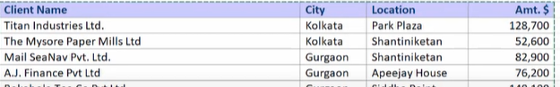

Criteria Table:

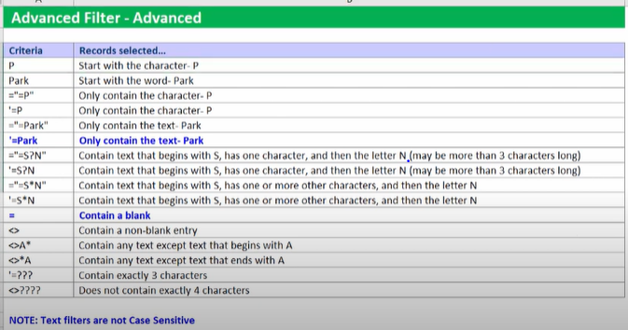

[Advanced Filter vs Basic Filter in Excel | Excel in Hindi (youtube.com)](https://www.youtube.com/watch?v=4QW7umf2V-4&list=PLrR4-diP9nFQMwAHNWCYG_5SDT_3boIYP&index=57)

* Fill Blank cells with above value in Excel –Ctrl+G->Special->Blanks->=Above cell->Ctrl+Enter

[Fill Blank cells with above value in Excel | Hindi (youtube.com)](https://www.youtube.com/watch?v=_L9Xah_Jsxk&list=PLrR4-diP9nFQMwAHNWCYG_5SDT_3boIYP&index=5)

* Goal Seek –**Back Calculate the Input based on a given Output.**

Data->What-If Analysis->Goal Seek->Set Cell(Target Cell)->To value(Target value)->By changing cell(Input cell gets back-calculated).

Goal seek is used when there is 1 constraint. In case of multiple constraints, use solver.

<https://www.youtube.com/watch?v=0DSRo_13ARw&list=PLrR4-diP9nFQMwAHNWCYG_5SDT_3boIYP&index=63>

* **Solver** – Data->Solver->Set Objective->Select the cell to maximize/minimize/set the value of(Target Cell)->To->Max/Min/Value Of(Target Value)->By changing variable cells->Select the cells to change(Input cells gets back-calculated)->Subject to the constraints->Add->Add the constraint->Add->Cancel->Make unconstrained Variables Non-Negative->select a solving method->GRG Nonlinear->Solve->keep solver solution
* **Data Table** – Select the table->Data->What-if analysis->Data Table->Column input cell->Select the cell in which the column is to be inputted

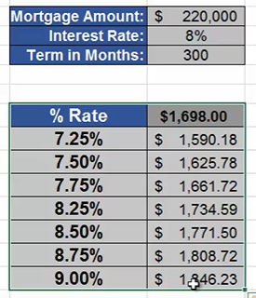

|  |  |
| --- | --- |
|  | Formula |
| Input 1 |  |
| Input 2 |  |

* **Scenario Manager** – Select the input cells that changes through diff. scenarios-> Data->What-if analysis->Scenario Manager->Add->Scenario name->Default Scenario->Add->Scenario name->Enter name of scenario->Enter values for each of the changing cells->1:->Enter new value->Select the scenario->Show.
* **Record Macro** – Developer->Code->record Macro->Macro name->Write name of macro->Do all the tasks->Stop Recording.
* **Edit Macro with VBA** – Developer->Code->Visual Basic->Double clk. on module(When we record macro using macro recorder, all the code gets stored inside module)->Edit code->Close.
* **Creating Buttons to run macros** – Developer->Controls->Insert->Form controls->Button(Form control)->Create the button->Select the macro->Click on the button to run the macro.
* MEDIAN(IF(lookup array=lookup value, return array)) – Equivalent of FORMULAIF()
* **Slicer to Filter Data –** select data->Ctrl+T->Table Design->Insert Slicer

[Excel Slicer to Filter Data | Excel in Hindi - YouTube](https://www.youtube.com/watch?v=I7eVVfdkHns&list=PLrR4-diP9nFQMwAHNWCYG_5SDT_3boIYP&index=66)

* **Group –** Select the columns/rows to be grouped->Data->Outline->Group->Group.

1 - Contract everything.

2 - Expand everything.

[How to Group in Excel (Rows & Columns) (youtube.com)](https://www.youtube.com/watch?v=mzvGv02ms3Y&list=PLrR4-diP9nFQMwAHNWCYG_5SDT_3boIYP&index=64)

* **Ctrl+[** - is used to select all cells directly referenced by formulas.

**Ctrl+G-**>Enter – Go back to the same cell.

* =[SORT](https://exceljet.net/functions/sort-function)(array,[sort_index],[sort_order],[by_col])

sort_index – Column/row index for sorting. Default is 1.

sort_order - -1 = Descending.

by_col -TRUE = sort by column.

* Pivot Table – Summarize data.

<https://www.youtube.com/watch?v=IIzLRnb5Udc&list=PLrR4-diP9nFQMwAHNWCYG_5SDT_3boIYP&index=59>

1. Convert raw data into table and then pivot so that when new rows are added in the raw data, the pivot table also gets updated when it is refreshed.
2. **Contribution Calculation** - Drag and drop values in sum of measure values for the 2nd time->Rt-Clk on 2nd value column->show values as->% of column total.
3. **Sort** – Rt-clk->Sort->Largest to Smallest.
4. **Chart** – F11
5. **Drill-down** - Double-clk on a value cell to get the underlying data for a particular R&C combination.
6. **Fill empty value cells** – Rt clk.->PivotTable Options->Layout & Format->For empty cells show->no.
7. **Grouping(nos.)-**Puttingno. on the row field->Rt-clk on row cell->Group.(Divide the nos. into brackets/clusters)

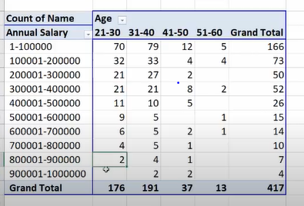

1. **Show items with no data-** Rt-clk on row cell->Field settings->Layout & Print->Show items with no data.

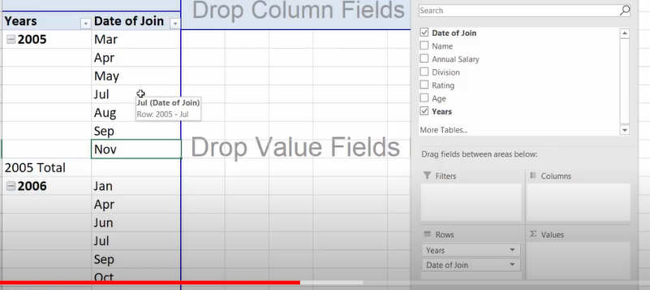

1. Move row/column names to beginning/end/up/down- Rt.clk on row/column name->move->move to beginning/end/up/down.
2. Rename row/column name-Clk on row/column name->rename it.
3. Group/Ungroup – Select the row/column names->Rt-Clk.->Group/Ungroup.
4. Slicer –

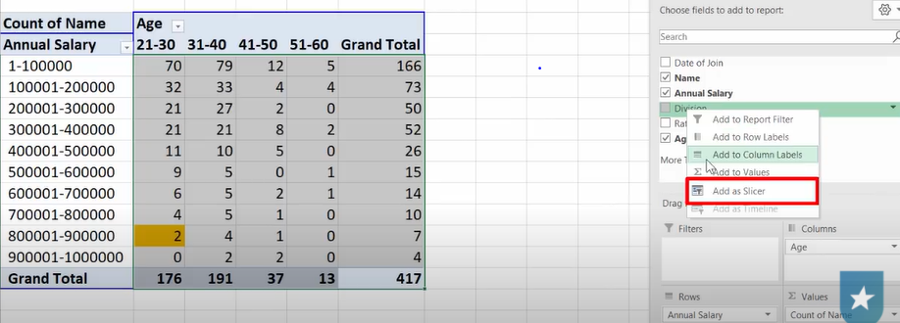

1. Timeline –

1. Count of values to Sum of values – Rt-Clk on value cells->Summarize values by->Sum
2. Heatmap/Data Bars – Select the value cells->Home->Conditional Formatting->Color Scales/Data Bars respectively.
3. Conditional formatting for all the groups containing value cells-

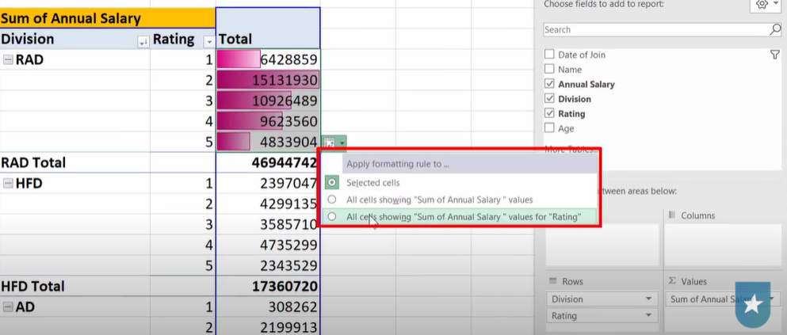

1. Remove/Activate Subtotal – Rt. Clk on row names->Subtotal Division.

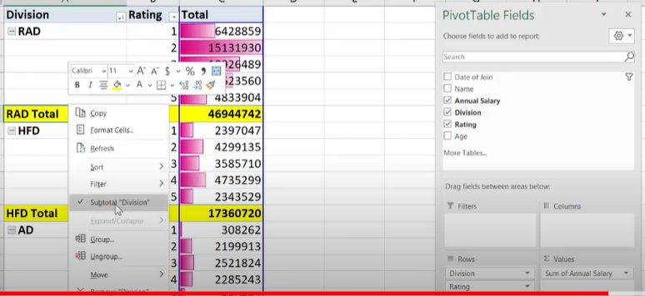

1. Expand/Collapse row names – Rt. Clk on row names->Expand/Collapse->Expand/Collapse Entire Field.

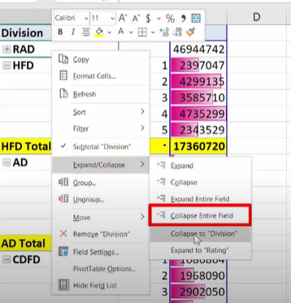

1. If underlying data changes – Rt. Clk on pivot table->Refresh.
2. New columns/rows are added in underlying data – Clk. On pivot table->PivotTable Analyze->Change Data Source-> Change Data Source->Select the data.
3. **Creating 100s of Pivot Table Reports in <1min** - Suppose u want to show names by division in each sheet. Put names in rows and Division in **filters**->PivotTable Analyze->PivotTable->Options-v->Show Report Filter Pages….->Select the filter(Multiple sheets are created for each value of the filter).

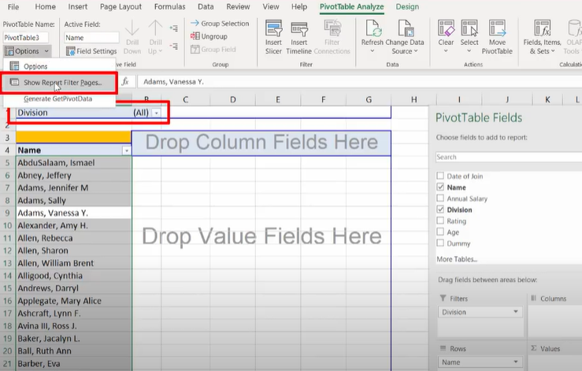

1. Select multiple sheets – Clk. On the starting sheet name->Shift+Clk. On last sheetname (All the sheets in between gets selected).
2. Disable =GETPIVOTDATA() for formula writing - PivotTable Analyze->PivotTable->Options-v->Generate GetPivotData(Untick).
3. Disable Autofit Column widths – Rt. Clk on value cells->PivotTable Options->Autofit column widths on update(Untick).

* **Power Pivot** – Used for **joining tables from multiple sheets and then pivot**.

1. **Join** - Select the data->Ctrl+T->Power Pivot->Add to data model.(Table data is connected to Power Pivot’s table data)->Do the same for the 2nd table->Home->Diagram view->Drag a column from 1st table and drop it on the same column from 2nd table(2 tables are joined).

(Alternatively, Rt. Clk on column name->Create relationship->Select 2 tables from dropdown and the common column from 2 tables)

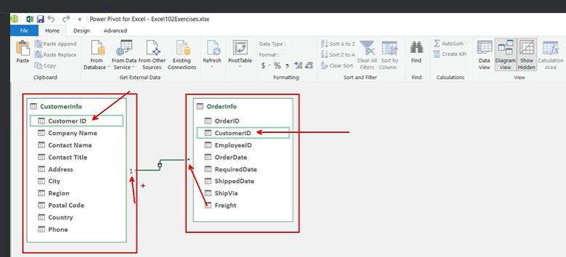

1. **Pivot** – Home->PivotTable->PivotTable->New Worksheet.(Any list which has been formatted as a table will be shown in PivotTable field list)

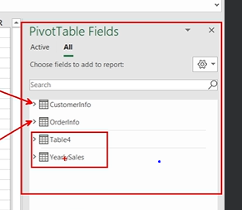

* **Import Dataset** – Data->Get Data->From File->From Excel Workbook->select the file->select multiple items->Select the sheets->Load->Load to->Table.
* **Data Cleaning** –

1. Use COUNTBLANK() to ensure that there are **no missing values** in key columns.
2. Alt+A+E – **Remove duplicates records** from data.

* Auto-Fill - + sign at the end of a cell.
* **Structured Reference** – Select the data->Ctrl+T(Converting into a table)->Table Design->Table Name->Change table name.

Then u can use structured references inside formulas like =SUM(Tablename[Columnname])

* **Custom List** – File->More->Options->Advanced->General->Edit Custom Lists->List Entries->Enter list entries in each line->Add.

**Use it to sort the data** – Select data->Sort->Sort by->Select column name->Order->Custom List->Select the Custom List.

* **Named Ranges** – Select the cells->Formulas->Define Name->Name->write the name.

Then u can use formulas like =SUM(rangename)

On the left of fx ,dropdown->select the named range to go to the range.

Disadvantage – Absolute reference.

Edit – Formulas->Name Manager->Select the named range->Edit it.

##### **Data validation** – Select the cells->Data->Data validation->Settings->Allow->Decimal->Data->greater than->Minimum->0. (Set up data validation rules to ensure sales amount are +ve nos.)

* **Conditional Formatting** – Home->Conditional Formatting->Top/Bottom Rules->Top(/Bottom) 10 %(/items)(Above/Below Average)

(Highlight top 10% of sales amounts)

* **Consolidating data from multiple sheets** – Select a cell where u want the result to be->Data->Consolidate->Function->Sum->Reference->Select data from multiple sheets->Add->Use labels in->Left column->Top row->Create links to source data.
* **Watch Window** – Select the cell to watch as u work in other locations->Formulas->Watch Window->Add Watch->Add. It will show book,sheet,name,cell,value and formula.